### INTRODUCTION

Crowd funding, to put it simply, is the practice of a group of individuals raising money for a project or campaign without the aid of established institutions like banks or loan providers. Crowdfunding, according to Freedman and Nutting, is a technique for gathering numerous modest donations over an internet platform. Fundraising tool to help fund or capitalize on a well-known business. The crowdfunding campaign consisted primarily of the contributors, the crowdfunding platform, and the project administrators are the three parties. Some common most popular crowdfunding websites are kickstarter.com, indiegogo.com, and mystartr.com. Crowdfunding is a new and innovative method for funding various kinds of ventures, where in individual founders of the ventures can request for funds. The ventures may be working for profit motive, cultural or social. The funds are usually given in return for future products or equity. It includes the use of internet social media platforms to connect investors with entrepreneurs in order to raise capital for various kinds of ventures in return for compensation. The emergence of new technologies has great potential in crowdfunding organizations as well as individuals. Crowdfunding platforms using the blockchain technology increase the credibility of various projects and ventures and therefore attract huge funds from investors and donors.

Keywords: Crowdfunding, Blockchain Technology, Synergy, Smart Contracts

Crowdfunding is basically the practice of funding a project or a start-up through raising money from various individuals. It is usually done using the internet, as it is easily accessible to gather contacts and determine the stakeholders of the project. Crowdfunding can be a suitable method for personal use, for real estate, loans, start-ups, and other businesses. Crowdfunding is emerging as one of the most affordable and viable options for young entrepreneurs in the country. Some of the best examples of crowdfunding platforms are Kickstarter, Indiegogo, Startengine, Ketto, etc. These platforms encourage entrepreneurship and are most-commonly used for creative projects, everything from music, art, films as well as technology. They usually charge a fee of around 4%-5%. Sometimes, the rewards are in the form of products or even being a part of the designing activity.

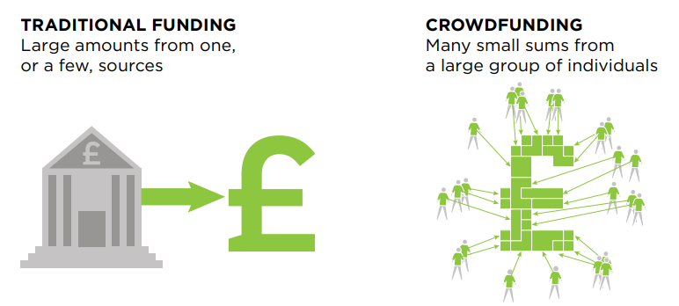

**Fig 1.1 Traditional funding vs crowdfunding.**

**The following are four technological innovations that have contributed to the growth of modern crowdfunding:**

**An online place for pitches:**

Crowdfunding platforms, in one sense, function as sophisticated online notice boards. By enabling campaigns to have a secure and trustworthy home online, where they can outline to potential funders what the project is about, the timescales, how much money is needed and what funders get in return. This provides a single place, that isn’t limited by geography or its capacity to engage a limited amount of people at a time, where entrepreneurs can send people interested in funding their campaign.

**Moving your money with a click:**

A key element of crowdfunding is the safe transfer of money from funder to entrepreneur at the end of a successful campaign. Crowdfunding campaigns and the platforms they use rely on the secure, easy and low–cost transfer of money from funders who are, in many cases very geographically dispersed. This is being provided to most platforms by online services such as PayPal10 and Amazon Flexible Payments (AFP).11 The importance of these services to the model was highlighted recently when Amazon denied crowdfunding platform unglue.it, which raises funding to gain Creative Commons licenses for books, usage of their AFP service, forcing the platform to temporarily halt its business.

**The social engine:**

While platforms provide the noticeboard for entrepreneurs to convey their pitch to would–be funders, it’s primarily activities outside the platform that drive traffic towards campaigns. Mail–outs and social media like Facebook (more than a billion14 users) Twitter (half a billion15 users) as well as free blogs like WordPress or Tumblr provide outlets for entrepreneurs to market their project. They allow the efficient targeting of online communities with a potential interest in backing the project and drive them towards their campaign with just a click.

**Fuelling campaigns with algorithms:**

Using algorithms platforms that are able to easily monitor and display campaign progress, both in terms of how much money has been pledged, by measuring traffic to campaigns and interest and buzz around the project. Crowdfunding platform Indiegogo for example uses an algorithm to measure the ‘gogo factor’,16 which take into account frequency of updates, tweets, comments, and click– throughs to the campaign, to decide which projects they are promoting on the platform front page in order to maximize overall success on the platform.

**1.1.Why Crowdfunding**

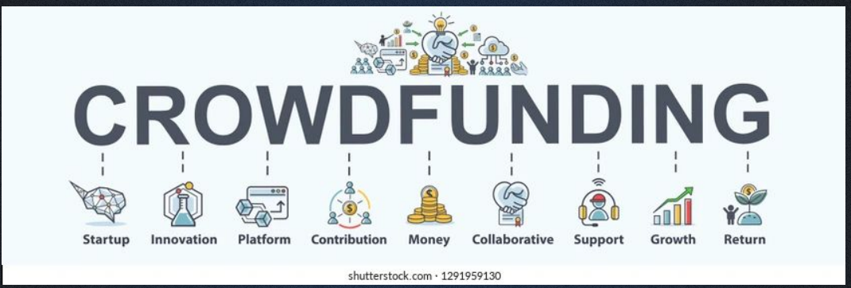

**Fig 1.2 Crowdfunding.**

* it can be a fast way to raise finance with no upfront fees
* pitching a project or business through the online platform can be a valuable form of marketing and result in media attention
* sharing your idea, you can often get feedback and expert guidance on how to improve it
* it is a good way to test the public's reaction to your product/idea - if people are keen to invest it is a good sign that the your idea could work well in the market
* investors can track your progress - this may help you to promote your brand through their networks
* ideas that may not appeal to conventional investors can often get financed more easily
* your investors can often become your most loyal customers through the financing process

**1.2. How crowdfunding will run**

With the growing popularity of crowdfunding as a way of raising business finance, it is important to consider how to make your campaign stand out from others. Here are some tips for a successful crowdfunding campaign.

**1. Think about your total investment goal:**

When setting your investment goal try to make it as low as possible. Calculate how much money you need to cover your campaign goal and any extra expenses, including the fee that the platform takes. Do not look at crowdfunding as a way to make profit at this stage. A target of £800 that is exceeded is much better than a target of £5,000 which is unsuccessful.

### Market your crowdfunding campaign

Marketing your crowdfunding campaign is central to its success. Crowdfunding platforms will host your project but it is your responsibility to promote your campaign before it starts. Set aside time before your campaign launch to use social media, press, networking, exhibitions, local radio and promotional materials to create a buzz around your project. Aim to have a number of interested investors ready to back your project on day one of your campaign.

### Create a video that captures your audience and promotes your project clearly

Set aside a video budget to make sure that it is interesting and clearly presents the benefitsof your project. When planning the content, create a video that can be used for future marketing opportunities to get the most for your money.

1. **Communicate effectively and honestly with all your backers and potential backers**

Make sure you communicate clearly about what your project is, what it is trying to achieve, how much money is needed to make it a reality and what you will deliver and when. Answer all questions that are directed at you. When possible answer the questions publically but in some cases you may prefer to reply privately.

### Be creative if you are offering rewards

If you decide to go for reward crowdfunding, let your potential backers know what's in it for them and make your rewards interesting if you can. One option is to offer different rewards for different levels of investment - this can encourage a potential backer to add more to their investment.

**1.3. Goal and scope of crowdfunding**

Crowdfunding is a way to raise funds for a specific cause or project by asking a large number of people to donate money, usually in small amounts, and usually during a relatively short period of time, such as a few months. Crowdfunding is done online, often with social networks, which make it easy for supporters to share a cause or project cause with their social networks.Organizations, businesses, and individuals alike can use crowdfunding for any type of project, for example: charitable cause, creative project, business startup, school tuition, or personal expenses. A quick scan across the different crowdfunding platforms and the projects they help get funding illustrates the diversity of what the crowd can finance. Uses of crowdfunding vary from funding video games to organic bakeries.

Some areas we see crowdfunding having a significant impact include:

1. **Crowdfunding creative and cultural industries**:

The creative industries were the driving force behind the rise of crowdfunding. Kickstarter and Indiegogo, arguably the most popular crowdfunding platforms, still focus mainly on creative projects, such as video games, photography or new design products. There are, however many more platforms concentrating on creative projects, many operating in specific niches such as publisher Unbound and unglue.it who are focusing on removing copyrights on books or emphasis is who focuses purely on funding photography projects.

1. **Crowdfunding private business**:

Crowdfunding also allows for investing in, and lending to private businesses. Through equity crowdfunding platforms like Crowdcube and Seedrs, people have the opportunity to get an equity stake in innovative UK businesses like Escape the City and DigitalSpin in exchange for contributing funds. Other platforms offer the opportunity to access crowdfunded loans. FundingCircle has thus far facilitated approximately £100 million in lending to more than 1,700 UK businesses offering interest rates of around 9 per cent to lenders before fees.

1. **Crowdfunding public and social projects**:

Civic crowdfunding is generally being used as a catch-all term for projects with a public or social focus, and is another application that has the potential to disrupt how money for charitable causes is sourced and how public services and spaces are used and paid for. The Luchtsingel footbridge in Rotterdam (in the Netherlands) is one early example of how local people crowdfunded a public good project, in return for getting their names on one of the 17,000 planks used to build the bridge. Spacehive in the UK has been pioneering co-investment models between the crowd, private sector, and public sector investors, with early successes like the Glyncoch Community Centre. While the majority of civic crowdfunding happens on the periphery of public services the Citizinvestor platform in the US has begun experimenting with integrating a crowdfunding into how the city of Philadelphia commissions and funds new public projects. Civic crowdfunding has also been proven as a new way of financing projects that have their origin in the third sector. Platforms like Peoplefund.it, SolarSchools and Buzzbnk are all examples of UK–based platforms that support projects with a social objective and are proving innovative models of encouraging more giving in society.

**1.4. Process Of Crowdfunding:** 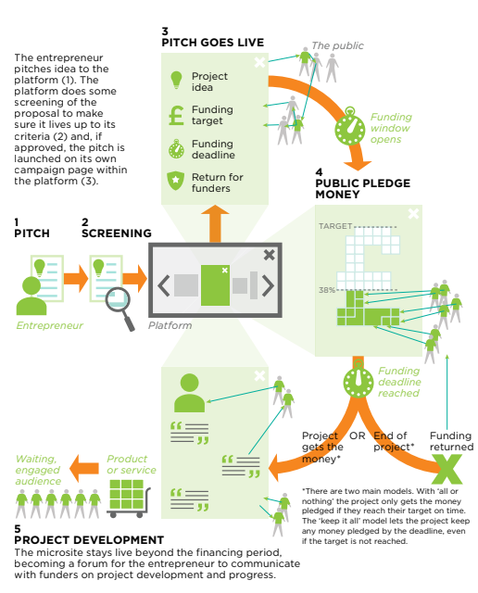

**Fig 1.3 Process Of Crowdfunding**

**2. LITERATURE SURVEY**

There are two literature reviews on crowdfunding. Bachmann et al. ( 2011 ) discuss the main results of 43

scientiﬁc articles on peer-to-peer lending. Feller, Gleasure, and Treacy (2013 ) structure research on

crowdfunding quantitatively according to the different forms of crowdfunding without considering the

speciﬁc contents of these studies. There is no comprehensive overview of crowdfunding literature

focusing on companies as capital-seeking parties. The following review closes this research gap.

There are two literature reviews on crowdfunding. Bachmann et al. ( 2011 ) discuss the main results of 43

scientiﬁc articles on peer-to-peer lending. Feller, Gleasure, and Treacy (2013 ) structure research on

crowdfunding quantitatively according to the different forms of crowdfunding without considering the

speciﬁc contents of these studies. There is no comprehensive overview of crowdfunding literature

focusing on companies as capital-seeking parties. The following review closes this research gap.

There are two literature reviews on crowdfunding. Bachmann et al. ( 2011 ) discuss the main results of 43

scientiﬁc articles on peer-to-peer lending. Feller, Gleasure, and Treacy (2013 ) structure research on

crowdfunding quantitatively according to the different forms of crowdfunding without considering the

speciﬁc contents of these studies. There is no comprehensive overview of crowdfunding literature

focusing on companies as capital-seeking parties. The following review closes this research gap

11In the last few years, crowdfunding has emerged as an alternative source of funding

One of the most comprehensive definitions of CF is provided by Mollick (2014). According to this author, CF “refers to the efforts by entrepreneurial individuals and groups—cultural, social, and for-profit—to fund their ventures by drawing on relatively small contributions from a relatively large number of individuals using the internet, without standard financial intermediaries” (Mollick 2014, p. 2). Similarly, Belleflamme et al. (2015) focus on an open call to provide financial resources that mostly takes place on an internet-based platform and links fundraisers to funders with the aim of funding a particular campaign by, typically, many funders. In these definitions, the important characteristics of this new financial mechanism are emphasized. The process could be initiated by a group or an individual for launching a new project of a cultural, social or for-profit nature. The funds are obtained from the crowd online, without financial intermediaries. However, this definition lacks the business models that might be used on CF.

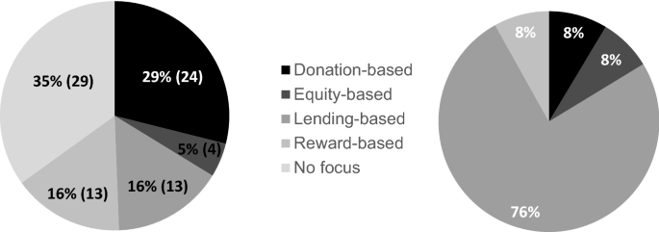

**Fig 2.1 .classification**

In almost every definition, there is no doubt that the development of internet and information technologies has increased the awareness and the participation of the “crowd” in financing entrepreneurial projects (Agrawal et al. 2015; Gajda and Mason 2013; Baumgardner et al. 2017). Therefore, new generations of entrepreneurs, especially Generation Z and Millennials, composed of more highly educated individuals, are well-positioned to take advantage of this new financial tool. However, depending on the purpose of the project, there are four business models for CF: donation-based, reward-based, lending-based and equity-based (Parhankangas et al. 2019). Whereas donation-based and reward-based models are regarded as non-investment models, lending-based and equity-based models are viewed as investment models.

In **donation-based crowdfunding**, backers provide funding based on philanthropic or civic motivations without expecting any return, to support disaster relief, famine, health and other charity-related programs. This model facilitates private contributions to public goods, ranging from the renovation of a public square in a neighbourhood to the maintenance of schools (Parhankangas et al. 2019). The platforms Justgiving.com and Gofundme.com are good examples of this model.

In **reward-based crowdfunding**, backers provide funding to individuals, projects, or organizations in exchange for special perks, early editions of new products, appreciation tokens or “community benefits” (Belleflamme et al. 2014). The backers are treated as early customers or “prosumers”, as they receive a product reward or a token of appreciation, such as a thank-you note, in return for their monetary contribution (Giudici et al. 2017). The platforms Kickstarter.com and Indiegogo.com are the leading companies in the world in this type of model.

In **lending-based crowdfunding** (also referred to as peer-to-peer lending or social lending), investors supply funds to individuals, groups or small companies, expecting to be reimbursed after a given period, generally with interest rates, without the involvement of traditional financial intermediaries (Guo et al. 2016). The lending-based model is the model that expands the most worldwide—half of the platforms operate under this model (Rau 2017). Some examples of this type of model are the platforms Kiva.org and Fundingcircle.com.

In **equity-based crowdfunding**, individuals or institutional funders purchase the equity of new ventures or enter into some sort of profit-sharing agreement with a company or organization (Deffains-Crapsky and Sudolska 2014; Ahlers et al. 2015). Examples of this type of model are the platforms Wefunder.com and Localstake.com.

Thus, crowdfunding, due to the different models that it encompasses, can be better suited to commercial or social entrepreneurship and can also be divided into investment and non-investment modes. The investment-related models comprise equity and lending CF, which are mainly applied in commercial CF, although economic ventures can also benefit from non-investment CF modalities, especially when the project is in the early stage of the entrepreneurial process. The non-investment-related models include donation- and reward-based CF, which are typically assigned to social entrepreneurship, since there is no financial return on investment, as the money is given as a donation, although it could evolve for some kind of reward. According to Paschen (2017), entrepreneurs should select the CF modality (donation, lending, equity) according to the startup stage of the project and the resources needed. In the beginning of a venture (pre-startup phase), organizational resources focus on validating the idea and a crowd provides valuable resources through funding and feedback on a proposed solution. In the next stage (startup), the resources needed are dedicated to validate the product and the market. In the final stage (growth), resources are required to market the offering and scale the venture’s operations

**3. SYSTEM DEVELOPMENT**

**3.1. Blockchain:**

Blockchain is one of the major tech stories of the past decade. Everyone seems to be talking about it—but beneath the surface chatter there’s not always a deep clear understanding of what blockchain is or how it works. Despite its reputation for impenetrability, the basic idea behind blockchain is pretty simple. And it has major potential to change industries from the bottom up. Blockchain is a technology that enables the secure sharing of information. Data, obviously, is stored in a database. Transactions are recorded in an account book called a ledger. A blockchain is a type of distributed database or ledger—one of today’s top tech trends—which means the power to update a blockchain is distributed between the nodes, or participants, of a public or private computer network. This is known as distributed ledger technology, or DLT. Nodes are incentivized with digital tokens or currency to make updates to blockchains.



**Fig 3.1 Blockchain.**

**Key Takeaways**

* Blockchain is a type of shared database that differs from a typical database in the way that it stores information; blockchains store data in blocks that are then linked together via cryptography.
* As new data comes in, it is entered into a fresh block. Once the block is filled with data, it is chained onto the previous block, which makes the data chained together in chronological order.
* In Bitcoin’s case, blockchain is used in a decentralized way so that no single person or group has control—rather, all users collectively retain control.
* Decentralized blockchains are immutable, which means that the data entered is irreversible. For Bitcoin, this means that transactions are permanently recorded and viewable to anyone.

**How Blockchain works ?**

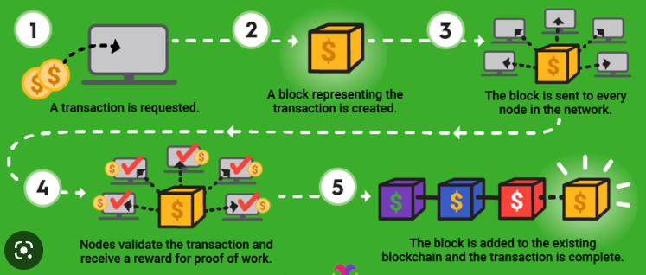

**Fig 3.2 Working of blockchain.**

The goal of blockchain is to allow digital information to be recorded and distributed, but not edited. In this way, a blockchain is the foundation for immutable ledgers, or records of transactions that cannot be altered, deleted, or destroyed. This is why blockchains are also known as a distributed ledger technology (DLT). Cryptography keys consist of two keys – Private key and Public key. These keys help in performing successful transactions between two parties. Each individual has these two keys, which they use to produce a secure digital identity reference. This secured identity is the most important aspect of Blockchain technology. In the world of cryptocurrency, this identity is referred to as ‘digital signature’ and is used for authorizing and controlling transactions. The digital signature is merged with the peer-to-peer network; a large number of individuals who act as authorities use the digital signature in order to reach a consensus on transactions, among other issues. When they authorize a deal, it is certified by a mathematical verification, which results in a successful secured transaction between the two network-connected parties. So to sum it up, Blockchain users employ cryptography keys to perform different types of digital interactions over the peer-to-peer network.

**3.2. Solidity:**

Solidity is an object-oriented, high-level language for implementing smart contracts. Smart contracts are programs which govern the behaviour of accounts within the Ethereum state.

* It's used to create smart contracts that implement business logic and generate a chain of transaction records in the blockchain system.
* It acts as a tool for creating machine-level code and compiling it on the Ethereum Virtual Machine (EVM).
* It has a lot of similarities with C and [C++](https://www.simplilearn.com/c-plus-plus-programming-for-beginners-article) and is pretty simple to learn and understand. For example, a “main” in C is equivalent to a “contract” in Solidity.

Like other programming languages, Solidity programming also has variables, functions, classes, arithmetic operations, string manipulation, and many other concepts.

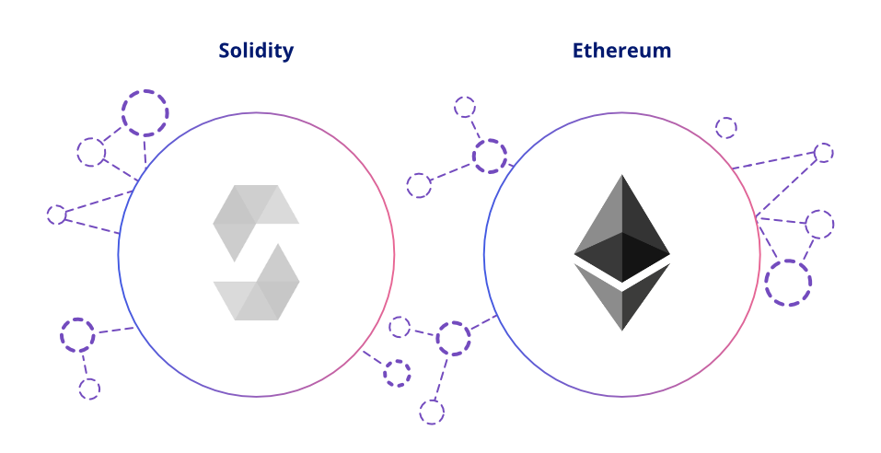

**Fig 3.3 Solidity**.

**3.3. EVM and Smart Contract:**

* The Ethereum Virtual Machine (EVM) provides a runtime environment for Ethereum smart contracts.
* It is primarily concerned with ensuring the security and execution of untrusted programs through the use of an international network of public nodes.
* EVM is specialized in preventing Denial-of-Service attacks and certifies that the programs do not have access to each other's state, as well as establishing communication, with no possible interference.

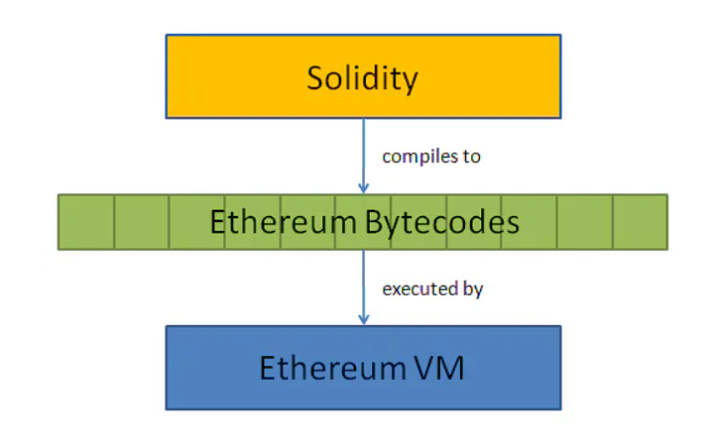

**Fig 3.4 Contract.**

### Smart Contracts :

### Smart contracts refer to high-level program codes compiled into EVM before being posted to the Ethereum blockchain for execution.

### It enables you to conduct trustworthy transactions without the involvement of a third party; these transactions are traceable and irreversible.

### Programming languages commonly used to create and write smart contracts are Serpent, Solidity, Mutan, and LLL.

### smart contract.png

### Fig 3.5 Smart Contract.

### Smart contracts are simply programs stored on a blockchain that run when predetermined conditions are met. They typically are used to automate the execution of an agreement so that all participants can be immediately certain of the outcome, without any intermediary’s involvement or time loss. They can also automate a workflow, triggering the next action when conditions are met.

### How Smart Contract Works:

Smart contracts work by following simple “if/when…then…” statements that are written into code on a blockchain. A network of computers executes the actions when predetermined conditions have been met and verified. These actions could include releasing funds to the appropriate parties, registering a vehicle, sending notifications, or issuing a ticket. The blockchain is then updated when the transaction is completed. That means the transaction cannot be changed, and only parties who have been granted permission can see the results. Within a smart contract, there can be as many stipulations as needed to satisfy the participants that the task will be completed satisfactorily. To establish the terms, participants must determine how transactions and their data are represented on the blockchain, agree on the “if/when...then…” rules that govern those transactions, explore all possible exceptions, and define a framework for resolving disputes. Then the smart contract can be programmed by a developer – although increasingly, organizations that use blockchain for business provide templates, web interfaces, and other online tools to simplify structuring smart contracts.

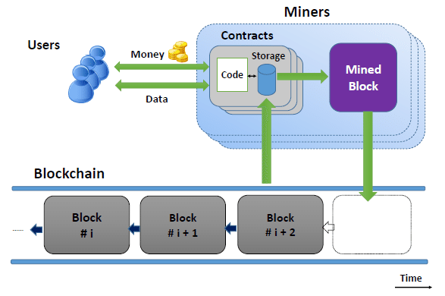

**Fig 3.6 Working.**

**3.4. Cryptocurrency:**



**Fig 3.7 Crypto.**

Cryptocurrency, sometimes called crypto-currency or crypto, is any form of currency that exists digitally or virtually and uses cryptography to secure transactions. Cryptocurrencies don't have a central issuing or regulating authority, instead using a decentralized system to record transactions and issue new units. Cryptocurrency is a digital payment system that doesn't rely on banks to verify transactions. It’s a peer-to-peer system that can enable anyone anywhere to send and receive payments. Instead of being physical money carried around and exchanged in the real world, cryptocurrency payments exist purely as digital entries to an online database describing specific transactions. When you transfer cryptocurrency funds, the transactions are recorded in a public ledger. Cryptocurrency is stored in digital wallets.

**Examples of cryptocurrency:**

**Bitcoin**: Founded in 2009, Bitcoin was the first cryptocurrency and is still the most commonly traded. The currency was developed by Satoshi Nakamoto – widely believed to be a pseudonym for an individual or group of people whose precise identity remains unknown.

**Ethereum**: Developed in 2015, Ethereum is a blockchain platform with its own cryptocurrency, called Ether (ETH) or Ethereum. It is the most popular cryptocurrency after Bitcoin.

**Litecoin**: This currency is most similar to bitcoin but has moved more quickly to develop new innovations, including faster payments and processes to allow more transactions.

**Ripple**: Ripple is a distributed ledger system that was founded in 2012. Ripple can be used to track different kinds of transactions, not just cryptocurrency. The company behind it has worked with various banks and financial institutions.

**Non-Bitcoin cryptocurrencies** are collectively known as “altcoins” to distinguish them from the original.

**3.5. Mining:**

### mining.png

### Fig 3.8 Mining.

Mining is the process that Bitcoin and several other cryptocurrencies use to generate new coins and verify new transactions. It involves vast, decentralized networks of computers around the world that verify and secure blockchains – the virtual ledgers that document cryptocurrency transactions. In return for contributing their processing power, computers on the network are rewarded with new coins. It’s a virtuous circle: the miners maintain and secure the blockchain, the blockchain awards the coins, the coins provide an incentive for the miners to maintain the blockchain.

**How Does Mining Work:**

There are three primary ways of obtaining bitcoin and other cryptocurrencies. You can buy them on an exchange like Coinbase, receive them as payment for goods or services, or virtually “mine” them. It’s the third category that we’re explaining here, using Bitcoin as our example.

* Specialized computers perform the calculations required to verify and record every new bitcoin transaction and ensure that the blockchain is secure. Verifying the blockchain requires a vast amount of computing power, which is voluntarily contributed by miners.
* Bitcoin mining is a lot like running a big data center. Companies purchase the mining hardware and pay for the electricity required to keep it running (and cool). For this to be profitable, the value of the earned coins has to be higher than the cost to mine those coins.
* What motivates miners? The network holds a lottery. Every computer on the network races to be the first to guess a 64-digit hexadecimal number known as a “hash.” The faster a computer can spit out guesses, the more likely the miner is to earn the reward.
* The winner updates the blockchain ledger with all the newly verified transactions – thereby adding a newly verified “block” containing all of those transactions to the chain – and is granted a predetermined amount of newly minted bitcoin. (On average, this happens every ten minutes.) As of late 2020, the reward was 6.25 bitcoin – but it will be reduced by half in 2024, and every four years after. In fact, as the difficulty of mining increases, the reward will keep decreasing until there are no more bitcoin left to be mined.
* There will only ever be 21 million bitcoin. The final block should theoretically be mined in 2140. From that point forward, miners will no longer rely on newly issued bitcoin as reward, but instead will rely on the fees they charge for making transactions.

### 3.6. Hyperledger:

### hyper.png

### Fig 3.9 Hyperledger.

### Hyperledger is an open source project created to support the development of blockchain-based distributed ledgers. Hyperledger consists of a collaborative effort to create the needed frameworks, standards, tools and libraries to build blockchains and related applications. Since Hyperledger's creation by the Linux Foundation in 2016, the project has had contributions from organizations such as IBM and Intel, Samsung, Microsoft, Visa, American Express and blockchain startups such as Blockforce. In all, the collaboration includes banking, supply chain management, internet of things (IOT), manufacturing and production-based fields. Hyperledger acts as a hub for different distributed ledger frameworks and libraries. With this, a business could use one of Hyperledger's frameworks, for example, to improve the efficiency, performance and transactions in their business processes. Hyperledger works by providing the needed infrastructure and standards for developing blockchain systems and applications. Developers use Hyperledger Greenhouse (the frameworks and tools that make up Hyperledger) to develop business blockchain projects. Network participants are all known to each other and can participate in consensus-making processes.

**3.7. Hardhat:**

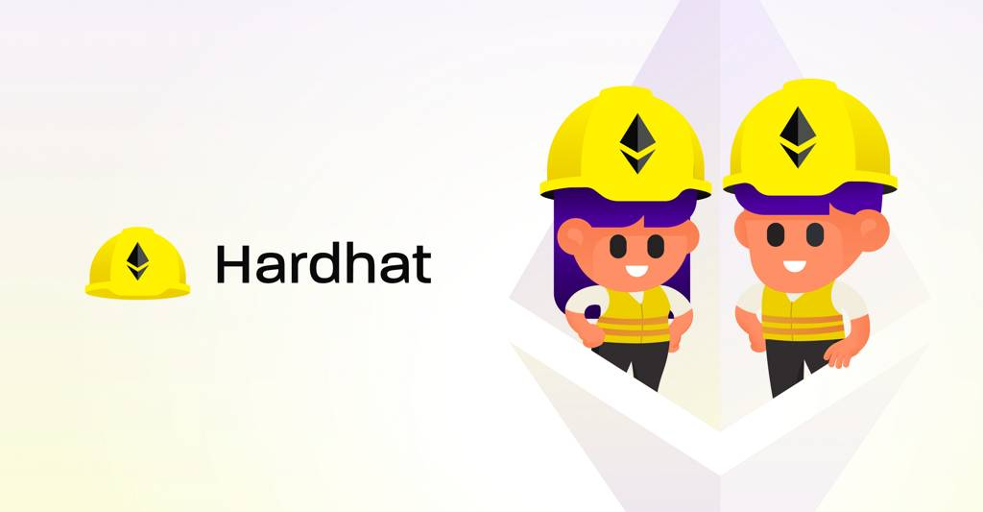

**Fig 3.10 Hardhat.**

Hardhat is a development environment for Ethereum software. It consists of different components for editing, compiling, debugging and deploying your smart contracts and dApps, all of which work together to create a complete development environment. Hardhat Runner is the main component you interact with when using Hardhat. It's a flexible and extensible task runner that helps you manage and automate the recurring tasks inherent to developing smart contracts and dApps. Hardhat Runner is designed around the concepts of tasks and plugins. Every time you're running Hardhat from the command-line, you're running a task. For example, npx hardhat compile runs the built-in compile task. Tasks can call other tasks, allowing complex workflows to be defined. Users and plugins can override existing tasks, making those workflows customizable and extendable. This guide will take you through the installation of our recommended setup, but as most of Hardhat's functionality comes from plugins, you are free to customize it or choose a completely different path.

**Installation:**

Hardhat is used through a local installation in your project. This way your environment will be reproducible, and you will avoid future version conflicts.

To install it, you need to create an npm project by going to an empty folder, running npm init, and following its instructions. You can use another package manager, like yarn, but we recommend you use npm 7 or later, as it makes installing Hardhat plugins simpler.

**npm install --save-dev hardhat.**

**3.8. Thidweb:**



**Fig 3.11 Thirdweb**

Thirdweb is a development framework that allows you to build web3 functionality into your applications. We provide workflows to speed up your development, including:

* **Contracts** you can use to build the foundation of your web3 functionality.
* **SDKs** to create applications that interact with the blockchain in your favorite languages.
* **Dashboards** to manage your contract settings, team permissions, revenue streams, and analytics.

**Contracts:**

Deploying smart contracts is the first step of building any web3 application. You can deploy one of our prebuilt contracts for more common use cases (NFTs, tokens, marketplaces), or you can build your own smart contract with our Contract Kit and ship it with Deploy.

**SDKs:**

We provide a diverse set of tools to help you build your applications with whatever languages and frameworks you are most comfortable using:

We have SDKs to handle interaction with your contracts in multiple languages and offer plug-and-play frontend components to help you build elegant user interfaces around your smart contract functionality.

**Dashboard:**

Each contract you deploy comes with a dashboard to manage your applications.

This lets you perform common admin operations for your projects without any code, such as:

* Deploying new smart contracts and interacting with current contracts
* Configuring royalty and platform fees or other contract settings
* Issuing team-wide permissions to enable collaboration
* Gathering insights from your smart contract analytics

**3.9. VITE-JS:**



**Fig 3.12 Vite-JS.**

Vite is a build tool that aims to provide a faster and leaner development experience for modern web projects. It consists of two major parts:

* A dev server that provides rich feature enhancements over native ES modules, for example extremely fast Hot Module Replacement (HMR).
* A build command that bundles your code with Rollup, pre-configured to output highly optimized static assets for production.

Vite is opinionated and comes with sensible defaults out of the box, but is also highly extensible via its Plugin API and JavaScript API with full typing support.

**3.10. MetaMask:**

**­­­**

**Fig 3.13 Metamask.**

MetaMask is a software cryptocurrency wallet used to interact with the Ethereum blockchain. It allows users to access their Ethereum wallet through a browser extension or mobile app, which can then be used to interact with decentralized applications.MetaMask is developed by ConsenSys Software Inc., a blockchain software company focusing on Ethereum-based tools and infrastructure. MetaMask allows users to store and manage account keys, broadcast transactions, send and receive Ethereum-based cryptocurrencies and tokens, and securely connect to decentralized applications through a compatible web browser or the mobile app's built-in browser.Websites or other decentralized applications are able to connect, authenticate, and/or integrate other smart contract functionality with a user's MetaMask wallet (and any other similar blockchain wallet browser extensions) via JavaScript code that allows the website to send action prompts, signature requests, or transaction requests to the user through MetaMask as an intermediary.[citation needed]The application includes an integrated service for exchanging Ethereum tokens by aggregating several decentralized exchanges (DEXs) to find the best exchange rate. This feature, branded as MetaMask Swaps, charges a service fee of 0.875% of the transaction amount. As of November 2021, MetaMask's browser extension had over 21 million monthly active users, according to Bloomberg.

**How to create an account on MetaMask:**

When you create your MetaMask wallet, you will be given a Secret Recovery Phrase, and an account is automatically generated. You’ll see that as your Account 1 (default account). If you'd like to create and manage multiple MetaMask accounts, you could do so simply by creating more accounts. Each of these is then associated with the same Secret Recovery Phrase. If you want to re-add accounts after restoring your wallet using your Secret Recovery Phrase, take a look at

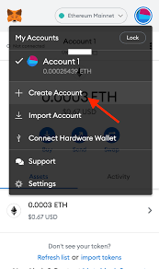

**Fig 3.14 create an account on MetaMask.**

**ER Diagram:**

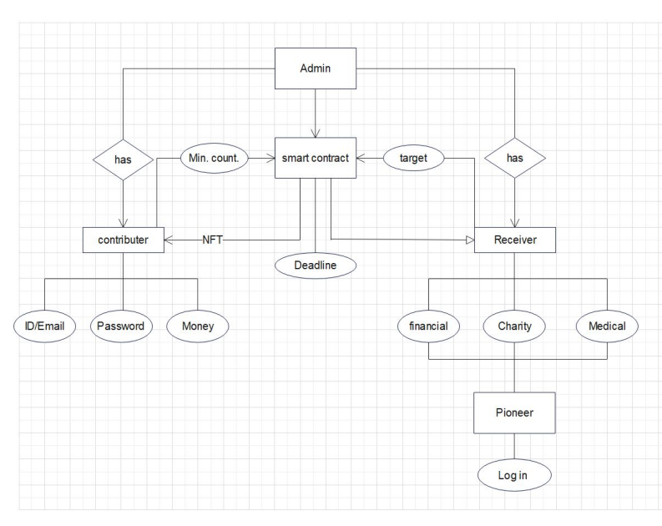

**Fig 3.15 ER Diagram.**

**Use Case:**

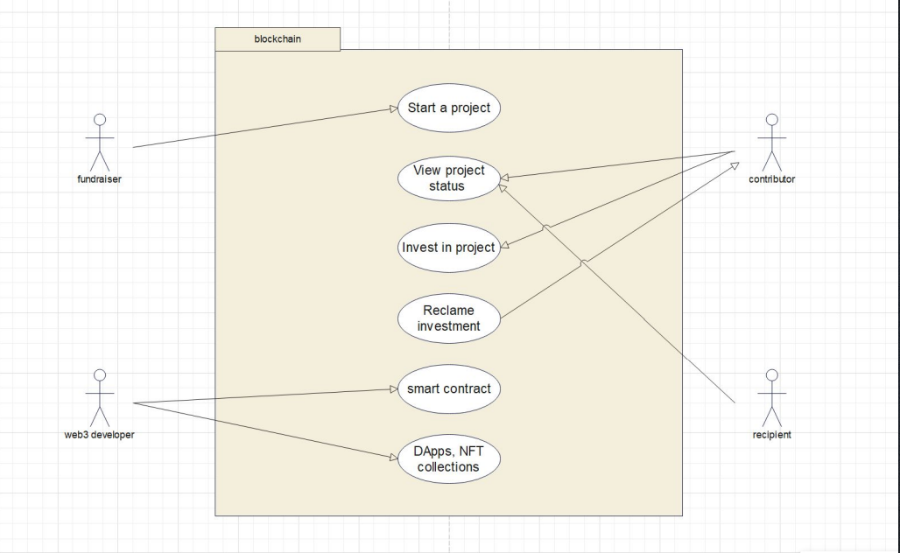

**Fig 3.16 Use Case.**

**Level 0 diagram:**

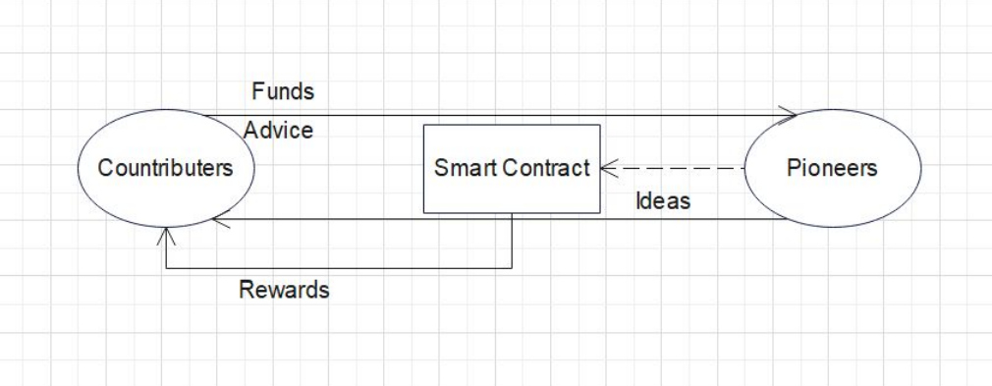

**Fig 3.16 Level 0 diagram.**

**Flowchart Diagram:**

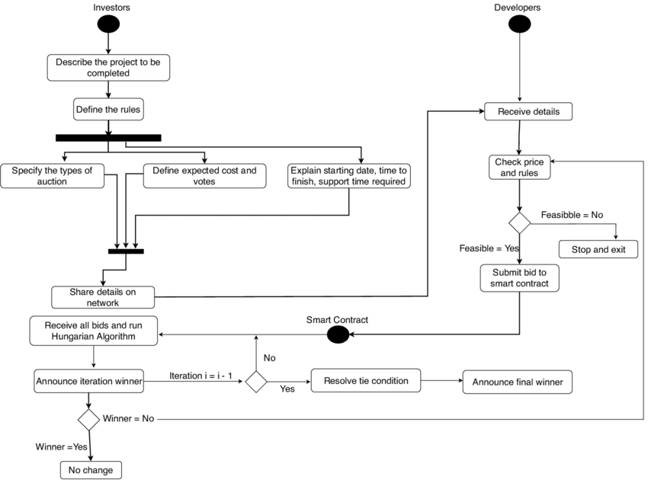

**Fig 3.17 Flowchart Diagram**

**Coding:**

**Module-1:**

import React from 'react';

import { useNavigate } from 'react-router-dom';

import FundCard from './FundCard';

import { loader } from '../assets';

const DisplayCampaigns = ({ title, isLoading, campaigns }) => {

  const navigate = useNavigate();

  const handleNavigate = (campaign) => {

    navigate(`/campaign-details/${campaign.title}`, { state: campaign })

  }

  return (

    <div>

      <h1 className="font-epilogue font-semibold text-[18px] text-white text-left">{title} ({campaigns.length})</h1>

      <div className="flex flex-wrap mt-[20px] gap-[26px]">

        {isLoading && (

          <img src={loader} alt="loader" className="w-[100px] h-[100px] object-contain" />

        )}

        {!isLoading && campaigns.length === 0 && (

          <p className="font-epilogue font-semibold text-[14px] leading-[30px] text-[#818183]">

            You have not created any campigns yet

          </p>

        )}

        {!isLoading && campaigns.length > 0 && campaigns.map((campaign) => <FundCard

          key={campaign.id}

          {...campaign}

          handleClick={() => handleNavigate(campaign)}

        />)}

      </div>

    </div>

  )

}

export default DisplayCampaigns

code of Home page

**Module-2:**

import React, { useState } from 'react'

import { useNavigate } from 'react-router-dom';

import { ethers } from 'ethers';

import { useStateContext } from '../context';

import { money } from '../assets';

import { CustomButton, FormField, Loader } from '../components';

import { checkIfImage } from '../utils';

const CreateCampaign = () => {

  const navigate = useNavigate();

  const [isLoading, setIsLoading] = useState(false);

  const { createCampaign } = useStateContext();

  const [form, setForm] = useState({

    name: '',

    title: '',

    description: '',

    target: '',

    deadline: '',

    image: ''

  });

  const handleFormFieldChange = (fieldName, e) => {

    setForm({ ...form, [fieldName]: e.target.value })

  }

  const handleSubmit = async (e) => {

    e.preventDefault();

    checkIfImage(form.image, async (exists) => {

      if(exists) {

        setIsLoading(true)

        await createCampaign({ ...form, target: ethers.utils.parseUnits(form.target, 18)})

        setIsLoading(false);

        navigate('/');

      } else {

        alert('Provide valid image URL')

        setForm({ ...form, image: '' });

      }

    })

  }

return (

    <div className="bg-[#1c1c24] flex justify-center items-center flex-col rounded-[10px] sm:p-10 p-4">

      {isLoading && <Loader />}

      <div className="flex justify-center items-center p-[16px] sm:min-w-[380px] bg-[#3a3a43] rounded-[10px]">

        <h1 className="font-epilogue font-bold sm:text-[25px] text-[18px] leading-[38px] text-white">Start a Campaign</h1>

      </div>

      <form onSubmit={handleSubmit} className="w-full mt-[65px] flex flex-col gap-[30px]">

        <div className="flex flex-wrap gap-[40px]">

          <FormField

            labelName="Your Name *"

            placeholder="John Doe"

            inputType="text"

            value={form.name}

            handleChange={(e) => handleFormFieldChange('name', e)}

          />

          <FormField

            labelName="Campaign Title *"

            placeholder="Write a title"

            inputType="text"

            value={form.title}

            handleChange={(e) => handleFormFieldChange('title', e)}

          />

        </div>

        <FormField

            labelName="Story *"

            placeholder="Write your story"

            isTextArea

            value={form.description}

            handleChange={(e) => handleFormFieldChange('description', e)}

          />

        <div className="w-full flex justify-start items-center p-4 bg-[#8c6dfd] h-[120px] rounded-[10px]">

          <img src={money} alt="money" className="w-[40px] h-[40px] object-contain"/>

          <h4 className="font-epilogue font-bold text-[25px] text-white ml-[20px]">

You will get 100% of the raised amount</h4>

        </div>

        <div className="flex flex-wrap gap-[40px]">

          <FormField

            labelName="Goal *"

            placeholder="ETH 0.50"

            inputType="text"

            value={form.target}

            handleChange={(e) => handleFormFieldChange('target', e)}

          />

          <FormField

            labelName="End Date *"

            placeholder="End Date"

            inputType="date"

            value={form.deadline}

            handleChange={(e) => handleFormFieldChange('deadline', e)}

          />

        </div>

        <FormField

            labelName="Campaign image *"

            placeholder="Place image URL of your campaign"

            inputType="url"

            value={form.image}

            handleChange={(e) => handleFormFieldChange('image', e)}

          />

          <div className="flex justify-center items-center mt-[40px]">

            <CustomButton

              btnType="submit"

              title="Submit new campaign"

              styles="bg-[#1dc071]"

            />

          </div>

      </form>

    </div>

  )

}

export default Create Campaign

**Code of Create Campaign.**

**Module-3:**

import React from 'react'

const FormField = ({ labelName, placeholder, inputType, isTextArea, value, handleChange }) => {

  return (

    <label className="flex-1 w-full flex flex-col">

      {labelName && (

        <span className="font-epilogue font-medium text-[14px] leading-[22px] text-[#808191] mb-[10px]">{labelName}</span>

      )}

      {isTextArea ? (

        <textarea

          required

          value={value}

          onChange={handleChange}

          rows={10}

          placeholder={placeholder}

          className="py-[15px] sm:px-[25px] px-[15px] outline-none border-[1px] border-[#3a3a43] bg-transparent font-epilogue text-white text-[14px] placeholder:text-[#4b5264] rounded-[10px] sm:min-w-[300px]"

        />

      ) : (

        <input

          required

          value={value}

          onChange={handleChange}

          type={inputType}

          step="0.1"

          placeholder={placeholder}

          className="py-[15px] sm:px-[25px] px-[15px] outline-none border-[1px] border-[#3a3a43] bg-transparent font-epilogue text-white text-[14px] placeholder:text-[#4b5264] rounded-[10px] sm:min-w-[300px]"

        />

      )}

    </label>

  )

}

export default FormField

**Code of Form field.**

**Module-4:**

import { tagType, thirdweb } from '../assets';

import { daysLeft } from '../utils';

const FundCard = ({ owner, title, description, target, deadline, amountCollected, image, handleClick }) => {

  const remainingDays = daysLeft(deadline);

  return (

    <div className="sm:w-[288px] w-full rounded-[15px] bg-[#1c1c24] cursor-pointer" onClick={handleClick}>

      <img src={image} alt="fund" className="w-full h-[158px] object-cover rounded-[15px]"/>

      <div className="flex flex-col p-4">

        <div className="flex flex-row items-center mb-[18px]">

          <img src={tagType} alt="tag" className="w-[17px] h-[17px] object-contain"/>

          <p className="ml-[12px] mt-[2px] font-epilogue font-medium text-[12px] text-[#808191]">Education</p>

        </div>

import React from 'react';

<div className="block">

          <h3 className="font-epilogue font-semibold text-[16px] text-white text-left leading-[26px] truncate">{title}</h3>

          <p className="mt-[5px] font-epilogue font-normal text-[#808191] text-left leading-[18px] truncate">{description}</p>

        </div>

<div className="flex justify-between flex-wrap mt-[15px] gap-2">

          <div className="flex flex-col">

            <h4 className="font-epilogue font-semibold text-[14px] text-[#b2b3bd] leading-[22px]">{amountCollected}</h4>

            <p className="mt-[3px] font-epilogue font-normal text-[12px] leading-[18px] text-[#808191] sm:max-w-[120px] truncate">Raised of {target}</p>

          </div>

          <div className="flex flex-col">

            <h4 className="font-epilogue font-semibold text-[14px] text-[#b2b3bd] leading-[22px]">{remainingDays}</h4>

            <p className="mt-[3px] font-epilogue font-normal text-[12px] leading-[18px] text-[#808191] sm:max-w-[120px] truncate">Days Left</p>

          </div>

        </div>

        <div className="flex items-center mt-[20px] gap-[12px]">

          <div className="w-[30px] h-[30px] rounded-full flex justify-center items-center bg-[#13131a]">

            <img src={thirdweb} alt="user" className="w-1/2 h-1/2 object-contain"/>

          </div>

          <p className="flex-1 font-epilogue font-normal text-[12px] text-[#808191] truncate">by <span className="text-[#b2b3bd]">{owner}</span></p>

        </div>

      </div>

    </div>

  )

}

export default FundCard

**Code of Fund Card.**

**Module-5:**

import React, { useState, useEffect } from 'react'

import { DisplayCampaigns } from '../components';

import { useStateContext } from '../context'

const Profile = () => {

  const [isLoading, setIsLoading] = useState(false);

  const [campaigns, setCampaigns] = useState([]);

  const { address, contract, getUserCampaigns } = useStateContext();

  const fetchCampaigns = async () => {

    setIsLoading(true);

    const data = await getUserCampaigns();

    setCampaigns(data);

    setIsLoading(false);

  }

  useEffect(() => {

    if(contract) fetchCampaigns();

  }, [address, contract]);

  return (

    <DisplayCampaigns

      title="All Campaigns"

      isLoading={isLoading}

      campaigns={campaigns}

    />

  )

}

export default Profile

**Code of Profile.**

**Module-6:**

import React from 'react';

import { Route, Routes } from 'react-router-dom';

import { Sidebar, Navbar } from './components';

import { CampaignDetails, CreateCampaign, Home, Profile } from './pages';

const App = () => {

  return (

    <div className="relative sm:-8 p-4 bg-[#13131a] min-h-screen flex flex-row">

      <div className="sm:flex hidden mr-10 relative">

        <Sidebar />

      </div>

      <div className="flex-1 max-sm:w-full max-w-[1280px] mx-auto sm:pr-5">

        <Navbar />

        <Routes>

          <Route path="/" element={<Home />} />

          <Route path="/profile" element={<Profile />} />

          <Route path="/create-campaign" element={<CreateCampaign />} />

          <Route path="/campaign-details/:id" element={<CampaignDetails />} />

        </Routes>

      </div>

    </div>

  )

}

export default App

**Code of App.**

**Outputs:**

**Home page:**

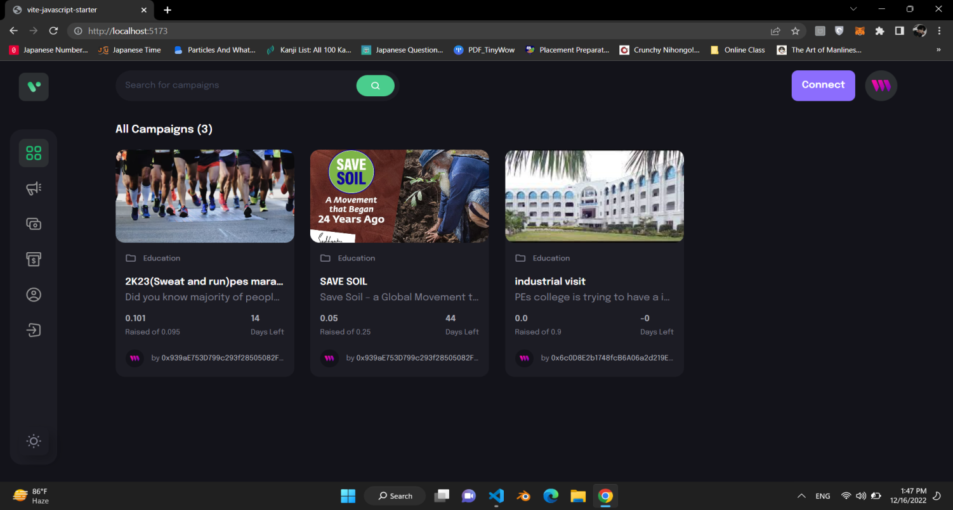

**Tractions:**

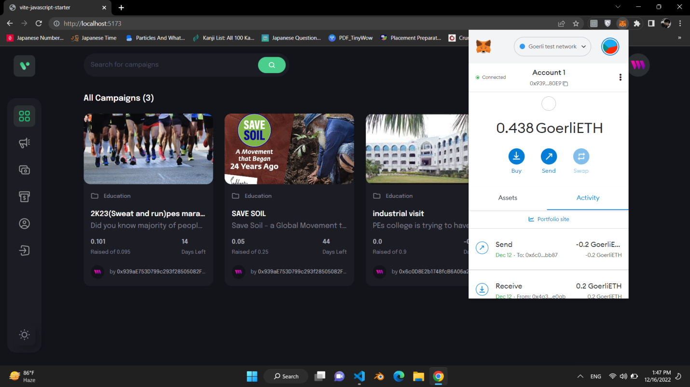

**View campaign:**

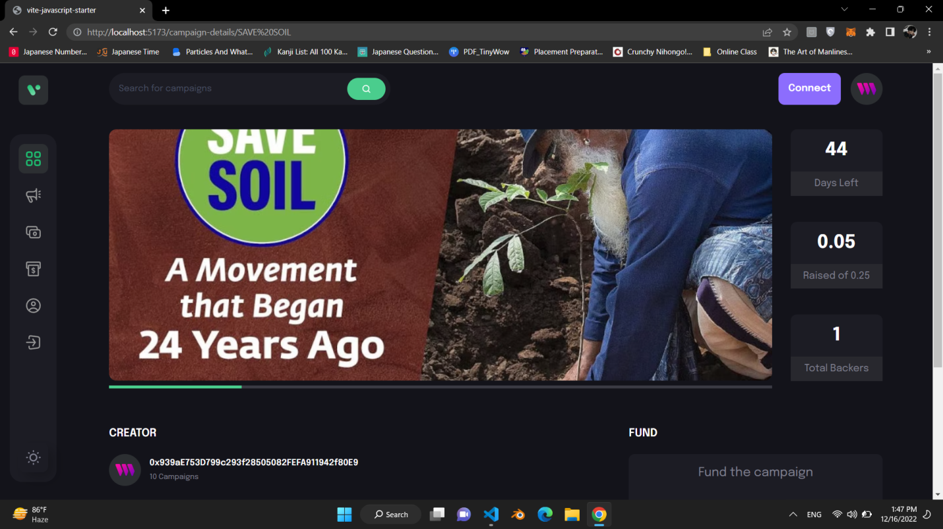

**Start a campaign:**

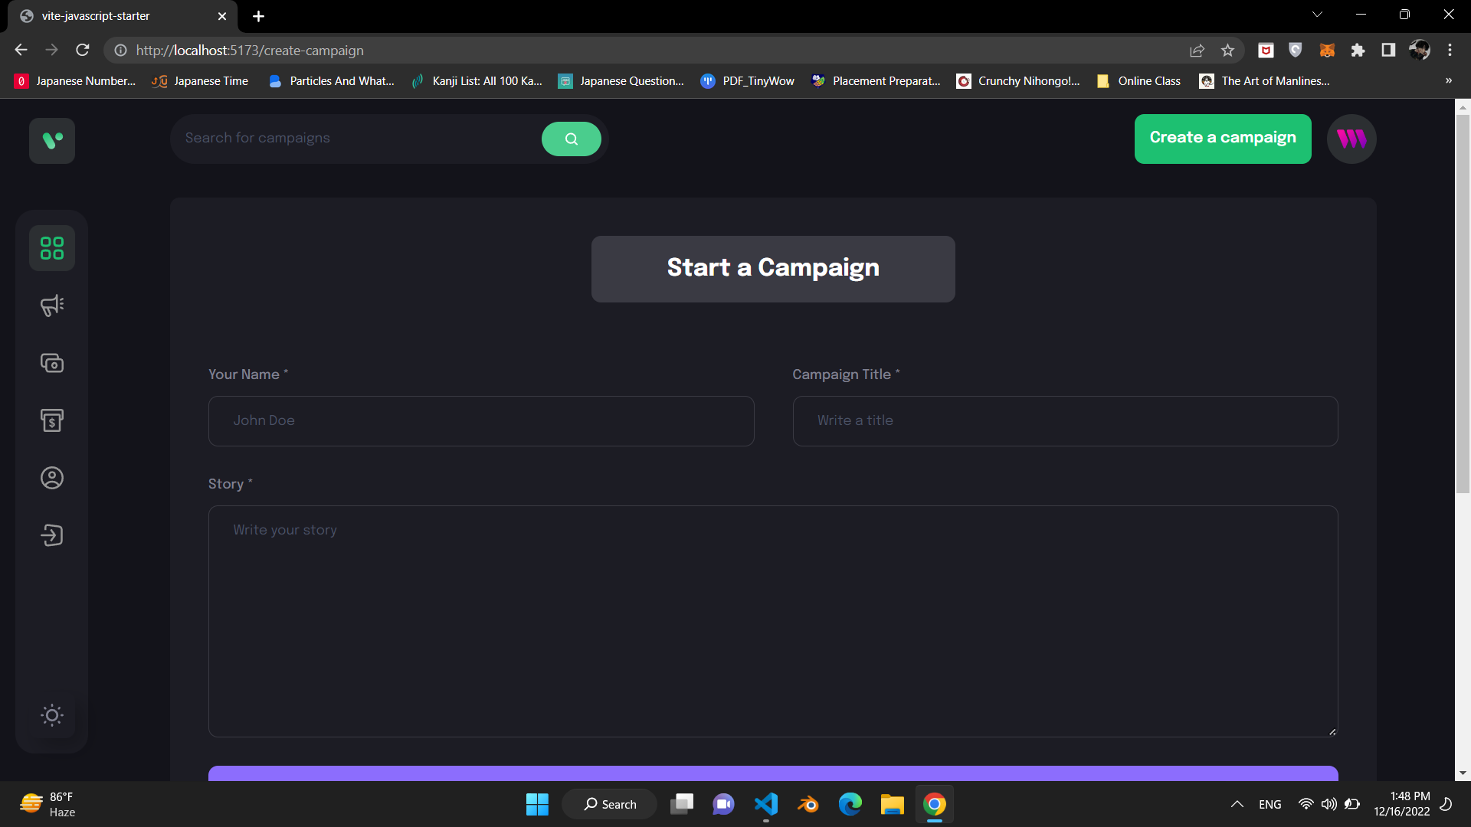

**CONCLUSION**

Crowdfunding not only provides money to organizations, it also boosts their man power as the crowd that funds them also puts their institutional structures on a broader footing. The supporters unwittingly become an additional marketing team by promoting the project they funded to their friends and networks. Another side-product of crowdfunding therefor is testing the popularity and effectiveness of a project with very little means, often before the project has even started. “An unexpected benefit of crowdfunding campaigns is that you will often receive very useful advice – and even tangible offers of assistance – from backers, Once an organization has gained some experience in crowdfunding, it can also branch out into crowdsourcing activities more easily, e.g. by integrating external resources and concepts like volunteering to support project work. Here, platforms like Volunteer Forever enter the picture, as they enable to financially support volunteers for going and working abroad.

On the one hand, non-profit organizations and charitable projects usually boast an existing network of supporters that they can activate for various purposes, including fundraising campaigns.

**REFERNCES**

1.<https://crowdfunding.milaap.org>

2.<https://www.impactguru.com>

3.<https://www.ketto.org>

3.<https://metamask.io>

4.<https://www.youtube.com>

5.[www.google.com](http://www.google.com)

6. <https://doi.org/10.1109/I-SMAC52330.2021.9640888>

7. <https://ieeexplore.ieee.org>

8. <https://ieeexplore.ieee.org>

**ACKNOWLEDGEMENT**

We would like to express my sincere thanks to our guide Mrs. Prof. S.R.Kamite , for her valuable guidance and support in completing my project. We would also like to express my gratitude towards our Head of Department of Computer Science & Engineering, for giving us this great opportunity to do a project on Crowdfunding Website. Without their support and suggestions, this project would not have been completed.

Prajwal Deshpande (B24)